

**Database Management System**

**CSE 303**

**Air Quality Monitoring System**

Final Report

Group 03

CHAPTER 01 : INTRODUCTION ....................................................................................................6

a. BACKGROUND OF THE ORGANIZATION.................................................................... 6

b. BACKGROUND OF THE PROJECT............................................................................... 6

c. OBJECTIVE OF THE PROJECT .................................................................................... 6

d. SCOPE OF THE PROJECT............................................................................................ 7

CHAPTER 02 : REQUIREMENT ANALYSIS..................................................................................8

e. RICH PICTURE (AS IS) .................................................................................................. 8

Figure 2. 1: Rich Picture (As Is) .............................................................................................8

f. SIX ELEMENT ANALYSIS (AS IS) ................................................................................. 9

Table 2. 1: Six Element Analysis (As Is).............................................................................9

**CHAPTER 01: INTRODUCTION**

**BACKGROUND OF THE ORGANIZATION**

Ministry of Environment, Forest and Climate Change which is formed by the government on 12 January 1972. At an initial state, the ministry's name was "Ministry of Environment and Forest" then on May,14,2018 cabinets changed the name to "Ministry of Environment and Climate Change". The role of the organization is to ensure a sustainable environment for the present and future generations of the country through conservation of ecosystem and environment, control of environmental pollution, adaptation measures for the impact of climate change, improvement of forest resources, and sustainable management of ocean resources.

**BACKGROUND OF THE PROJECT**

**OBJECTIVE OF THE PROJECT**

The most important factor to be considered in designing a monitoring system is the objective(s).

Air Quality Monitoring system acts as the baseline of any air quality management program for a specific area/region. The outcome of the air quality monitoring system basically indicates necessity and extent of controlling emission from the sources. This project has been entrusted with a vital role of processing and supplying regular air quality data to the policy makers, stakeholders, public and …… Air quality monitoring system results shows the actuality of pollution abatement measures taken by the authority in a city or a country. For example, the air quality monitoring results certified the improvement of the air quality in Dhaka city by about 40% after phasing out of two stroke three-wheel baby taxis in 2001.

So, the main purpose of this report is to present, explore and make available the air quality data generated at 8 major cities of Bangladesh to the public, stakeholders, researchers and policy makers.

**SPECIFIC OBJECTS OF THIS REPORTS ARE:**

* Locating contamination problem areas and understanding their spacetime changes.
* Complying with atmospheric air protection legislation.
* To assess the impacts of changes in source characteristics in the cities.
* Informing citizens regarding local air quality status

**We will complete this following steps in our Project**

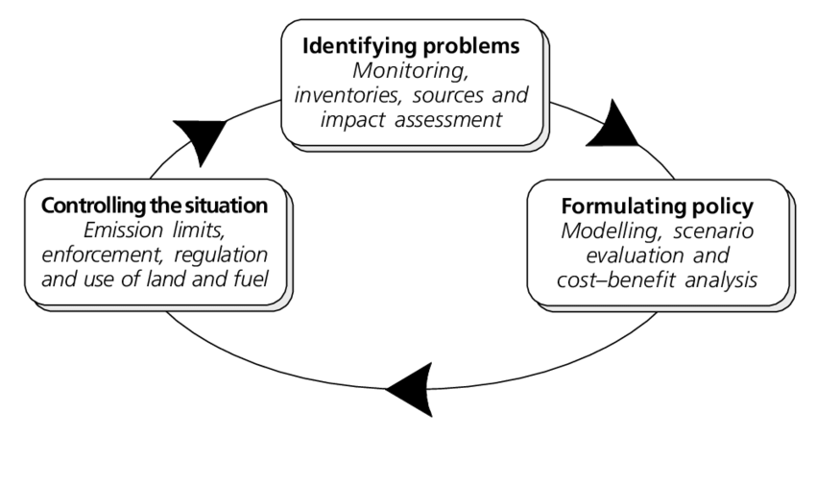

**SCOPE OF THE PROJECT**

The scope is to assist in the efficient and effective implementation of the project through

the following tasks:

• Facilitate the implementation, including planning and management

• Conduct monitoring of the project, including appraisal sub-projects by engineers and technical experts.

• Support for review and improvement of the project implementation

• Project Initiation

• Data Collection

• Measure Characterization

• Potential Modeling

• Program Analysis

• Reporting

• Project management

**CHAPTER 02: REQUIREMENT ANALYSIS**

**RICH PICTURE (AS IS)**

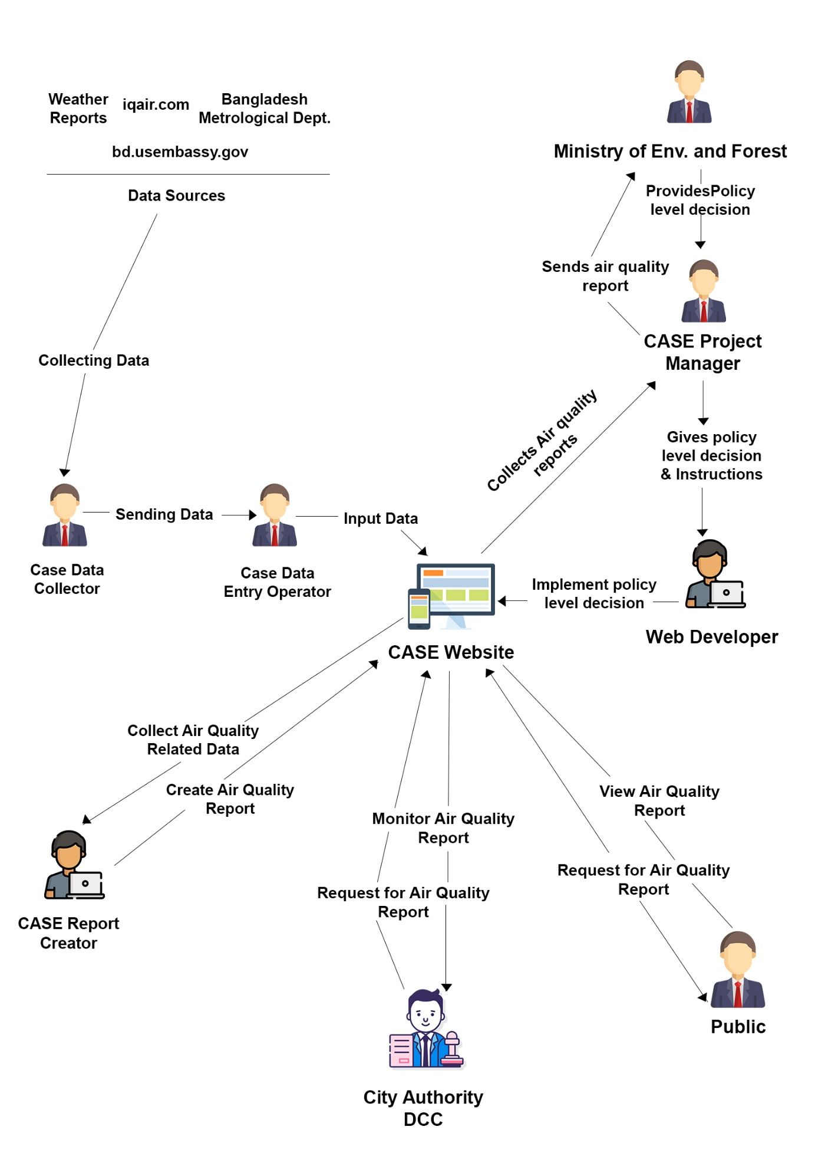

**SIX ELEMENT ANALYSIS (AS IS)**

Table 2. 1: Six Element Analysis (As Is)

|  |  |  |  |  |  |  |
| --- | --- | --- | --- | --- | --- | --- |
| **Process** | **System Roles** | | | | | |
|  | **Human** | **Non-computing Hardware** | **Computing Hardware** | **Software** | **Database** | **Communication & Network** |
| **Data Entry** | **A. Dept. Of ENV**  1. Explore the possible  sources of data.  2. Gather data from  different sources.  3. Select appropriate data  entry form.  4. Enter the data in the  system. Users need to  provide data entry options,  data period, correct unit,  and source related  information in the system.  5. Click on the save button  to store the data.  **B. Developer**  1. Logs into DBMS system.  2. Create new users for the  system for validation and  verification process from  time to time.  3. Using setting the users  can change different  system variables and other  parameters.  4. Keep track to make sure  all the processes are  running successfully.  **C. Internal IT Expert**  1. The DBMS system is  maintained by some IT  experts whose job is to  make sure the data is  always protected.  2. They must make sure  the website is always  running.  3. They have a backup  ready in case of power  failures as well.  **D. External IT Expert**  1. Server providers in the  DBMS system for managing  network resources so that  the same data can be  viewed by the other users as well from  anywhere around the  world.  2. The internet service  providers provide internet  connection to the users | **A.Paper**  **1.Paper is used**  **to deliver the**  **stored data**  **before inputting**  **in the system**  **2.Paper is used**  **for printing purpose**  **for manually storing**  **the database**  **B.Stationery**  **1.Pen and fluid**  **are used to make**  **any updates or**  **corrections**  **C.PDF**  **1.The datasheet**  **can be viewed as**  **a pdf in a computer**  **for data entry purposes**  **D.File holder**  **1.File holders are**  **used to store and**  **organize the data**  **sheets provided by**  **the data collectors**  **E.Cabinets**  **1.Cabinets are**  **used to store**  **files containing**  **datasheets.** |  | **A. DBMS Software**  **1. It is an**  **interface which**  **stores data and**  **is used by the**  **users for**  **data entries.**  **B. Operating**  **System**  **1. Any Operating**  **System used by**  **the data**  **sourcing team**  **and the**  **Users like Mac,**  **Windows, Linux.**  **C. Application**  **Software**  **1. Application**  **software used by**  **both the**  **Users and the**  **data sourcing**  **team like MS**  **Excel.**  **D. Web-based**  **Application**  **Software**  **1. Web based**  **application**  **software to**  **collect data from**  **the sources.**  **E. Scanning**  **Software**  **1. Data can be**  **scanned by the**  **Users if**  **they want to**  **store the data**  **manually.**  **F. Printing Software**  **1. Printing software used**  **for printing the**  **data sheet like**  **Printer**  **Management or**  **HP Print and**  **Scan Doctor.**  **G. PDF Viewer**  **1. Software used**  **to view the PDF**  **like WPS.** |  |  |
| **Data Verification & Data Update** | **A. Dept of ENV**  1. User logs into DBMS system.  2. User views the data provided by the data sources from the  DBMS System for verification and validation process.  3.They note down their contact from whom they would verify to start the validation process.  4. They make phone calls or email to verify the data from data sources.  5. They update the data in DBMS system after the verification is done.  7. Click on the save button to store the updated data.  6.They sign and seal the manual documents to verify the information.  **B. Developer**  1. Login into DBMS system.  2. Create new users for the system for validation and verification process from  time to time.  3. Using settings the users can change different system variables and other  parameters.  4. Keep track to make sure all the processes are running successfully.  **C. Internal IT Expert**  1. The DBMS system is maintained by some IT experts whose job is to make sure the data is always protected.  2. They must make sure the website is always running.  3. They have a backup ready in case of power failures as well.  **D. External IT Expert**  1. Server providers in the DBMS system for managing network resources so that the data can be viewed, verified, and updated by the other users from the DBMS system.  2. The internet service providers provide internet connection to the users to view, verify and update the data into the DBMS system. | **A.Paper**  **1.Paper is used to deliver the stored data before inputting in the system**  **2.Paper is used for printing purpose for manually storing the database**  **B.Stationery**  **1.Pen and fluid are used to make any updates or corrections**  **C.PDF**  **1.The datasheet can be viewed as a pdf in a computer for data entry purposes**  **D.File holder**  **1.File holders are used to store and organize the data sheets provided by the data collectors**  **E.Cabinets**  **1.Cabinets are used to store files containing datasheets** |  | **A. DBMS Software**  **1. The DBMS**  **system used by**  **the Users**  **to access the**  **data provided by**  **the data sources**  **for reviewing.**  **2. It is used to**  **input the**  **verified data.**  **3. It is used to**  **update the data**  **if required.**  **B. Application**  **Software**  **1. Application**  **software like MS**  **Office or any**  **other application**  **that were used**  **by the Users to review,**  **validate, and**  **update the data**  **after the data**  **was saved into**  **the PC by them.**  **C. Operating**  **System**  **1. Any Operating**  **System used by**  **the Users**  **and the Policy**  **Makers like Mac,**  **Windows, Linux.**  **D. Web-based**  **Application**  **Software**  **1. Users**  **will use**  **browsers to view**  **website to**  **log in to view,**  **verify and**  **update the data.**  **2. For research**  **purposes by the**  **User to verify the data.**  **E. Scanning Software**  **1. Data sheet**  **can be scanned**  **by the Users if they**  **want to store**  **the data**  **manually.**  **F. Printing**  **Software**  **1. Printing**  **software used**  **for printing the**  **data sheet by Users as**  **manual backup.**  **G. PDF Viewer**  **1. To view the**  **data sheet in**  **PDF version by**  **the Users.** |  |  |
| **Build and Update Report Templates** | **A. USERS**  1. Logs into DBMS System.  2. Selects the report template and inputs data to create report.  3. Create and edit the report template to put data in a systematic way, for an example: creating auto generated table and graphs to analysis the report or adding any option required by the policy makers to add into the template.  4. Clicks the save button to store the created and edited template.  **B. Admin**  1. Logs into system.  2. Create new users for the system to receive the generated report from  time to time.  3. Using settings the users can change different system variables and other parameters.  4. Keeps track to make sure all the processes are running successfully.  **C. Internal IT Expert**  1. Creates the report template creating and editing module in the  DBMS system for the users, so that they can create and edit templates.  2. Maintains the system so that if any mishaps occur, they can fix them.  **D. External IT Expert**  1. Server providers in the system for managing network resources so that the data can be viewed, and report can be generated by the other users from system.  2. The internet service providers provide internet connection to the users to generated report from and to the Policy Makers to view the report and do their own research. | **A.Paper**  **1.Paper is used to write**  **down/brainstorm new policies**  **2.Paper is**  **used to print the**  **finalized policies**  **B.Stationery**  **1.Pen is used to**  **write down policies**  **and sign official**  **documents. Fluid is**  **used to update and**  **make corrections**  **C.Seal stamps**  **1.Seal stamps are**  **used to authorize and**  **verify documents with**  **official government seals**  **D.File holder and Cabinets**  **1.File holders and**  **cabinets are used**  **to store and organize**  **official policy documents**  **E.Books/Journals/**  **Newspapers/Research Paper**  **1.Used to conduct**  **research on existing**  **and proposed policies**  **before making a**  **decision by the**  **policymakers** |  | **A. DBMS Software**  **1. It provides an**  **interface**  **through which**  **the Users**  **can design and**  **create the report**  **template.**  **B. Operating**  **System**  **1. Any Operating**  **System used by**  **the Users**  **like Mac,**  **Windows, Linux.**  **C. Application**  **Software**  **1. Internal IT**  **Expert will use**  **software like**  **Adobe Illustrator**  **to design the**  **templates of the**  **report.**  **D. Web-based**  **Application**  **Software**  **1. Users**  **will use**  **browsers to view**  **website to**  **input the report**  **and template.** |  |  |
| **Report Generation & Analysis** | **A. USERS**  **1. Logs into DASH System.**  **2. Selects report template**  **to generate the report.**  **3. Generates Report by**  **clicking the Generate**  **Report button, from the**  **data stored in DASH**  **System.**  **4. Clicks the save button to**  **store the Generated**  **Report.**  **5. Users store the**  **report for analysis process**  **led by the Policy Makers.**  **6. Sends the generated**  **report to the Policy**  **Makers for analysis**  **process.**  **7. Receives the feedback**  **from the Policy Makers as**  **policy level decisions.**  **8. Applies their policy level**  **decisions to their system.**  **B. Policy Makers**  **1. Receives the generated**  **report from Users.**  **2. Clicks save button to**  **store the report.**  **3. Analyzes the generated**  **report received from Users for strategical**  **decision making in future**  **and take policy level**  **decisions.**  **4. Makes strategical**  **decision for the future**  **betterment of the**  **company.**  **5. Let’s the Users**  **know about their feedback**  **as policy level decisions.**  **C. Developers**  **1. Logs into system.**  **2. Create new users for the**  **system to receive the generated report from**  **time to time.**  **3. Using setting the users**  **can change different**  **system variables and other**  **parameters.**  **4. Keeps track to make**  **sure all the processes are**  **running successfully.**  **D. Internal IT Expert**  1. The system is maintained by some IT  experts whose job is to  make sure the data is  always protected.  2. They must make sure  the website is always  running.  3. They have a backup  ready in case of power  failures as well.  **E. External IT Expert**  1. Server providers in the  system for managing  network resources so that  the data can be viewed,  and report can be  generated by the other  users from system.  2. The internet service  providers provide internet  connection to the  users to generated report  from DBMS System and to the  Policy Makers to view the  report and do their own  research. | **A.Paper**  **1.Paper is used**  **to deliver**  **reports to**  **city authorities**  **2.Paper is used**  **to write feedback**  **on reports**  **B.Stationery**  **1.Pen is used**  **to write notes**  **and comments**  **on reports**  **C.File holder**  **& Cabinets**  **1.File holders**  **and cabinets**  **are used to**  **store reports**  **and feedback summaries** |  | **A. DBMS Software**  **1. It is an**  **interface which**  **stores the data**  **and Users**  **generate the report based on**  **the data.**  **B. Operating**  **System**  **1. Any Operating**  **System used by**  **the Users**  **and the Policy**  **Makers like Mac,**  **Windows, Linux.**  **C. Application**  **Software**  **1. Policy Makers**  **can view the**  **report received**  **from the**  **Users.**  **D. Web-based**  **Application**  **Software**  **1. Users**  **will use**  **browsers to view**  **DBMS website to**  **log in to fetch**  **data and**  **generate the**  **report. Policy**  **Makers will use**  **browsers to**  **login and receive**  **the report from**  **the Users.**  **2. For research**  **purposes to**  **ensure**  **proposing the**  **best and**  **beneficial**  **policies.**  **E. Scanning**  **Software**  **1. Report can be**  **scanned by the**  **Users or**  **Policy Makers if**  **they want to**  **store the data**  **manually. Or if**  **the Users**  **want to send a**  **manual copy of**  **report to the**  **Policy Makers.**  **F. Printing**  **Software**  **1. Printing**  **software used**  **for printing**  **report as a**  **manual backup.**  **G. PDF Viewer**  **1. To view the**  **report in PDF**  **version by the**  **Users and**  **Policy Makers.** |  |  |

**PROCESS DIAGRAM**

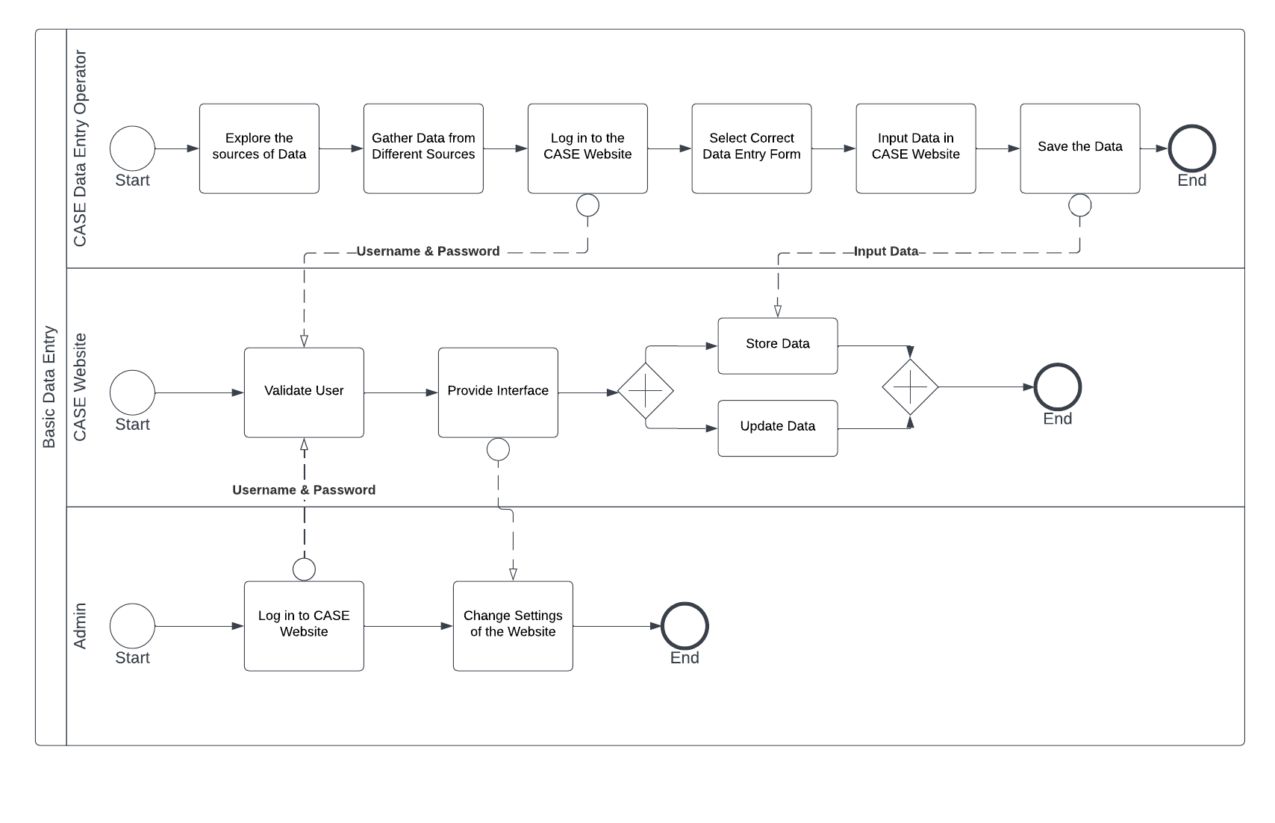

**Fig : Process Diagram Basic Data Entry(As is).**

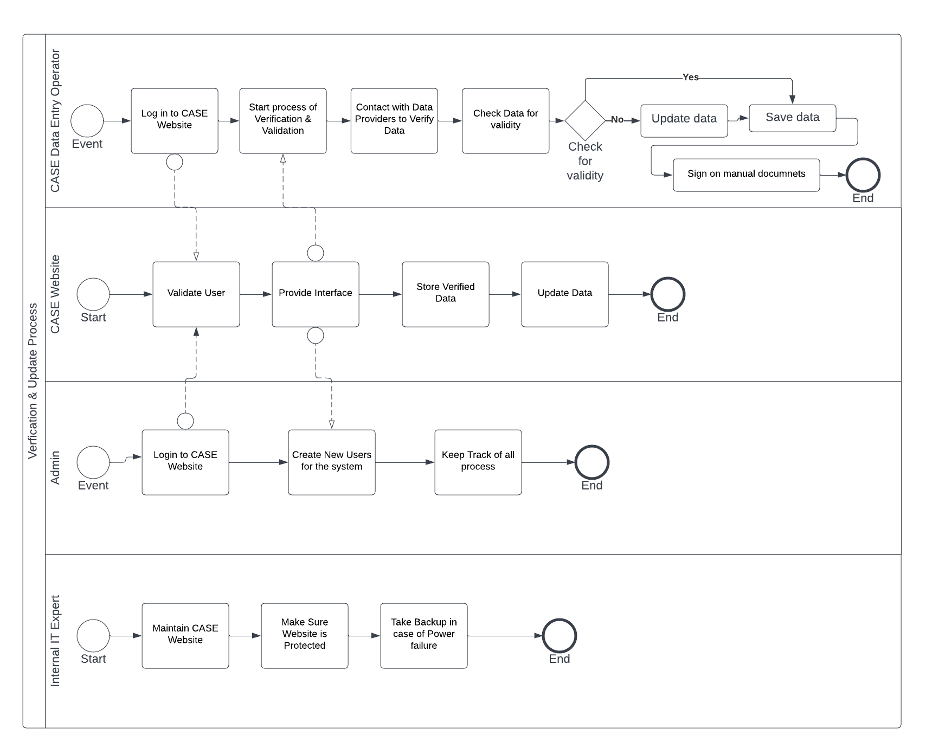

**Fig : Process Diagram Verification & update(As is).**

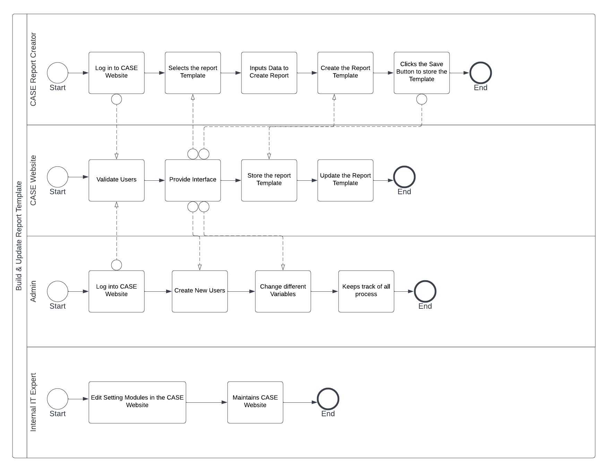

**Build & Update Report Template (As is)**

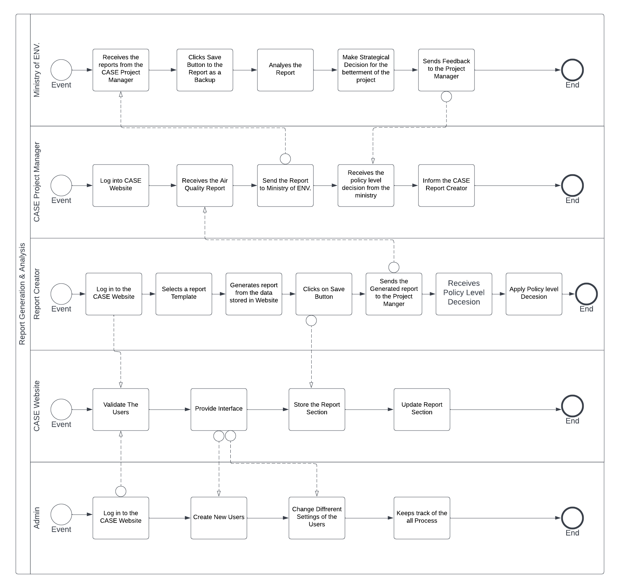

**Report Generation (As is)**

Problem Analysis

|  |  |  |  |  |
| --- | --- | --- | --- | --- |
| **Process Name** | **Stakeholders** | **Concerns (Problems)** | **Analysis (Reason of the Problem)** | **Proposed Solution** |
| **Basic Data Entry** | 1. CASE Data Entry Operator  2. CASE Data Collector | 1. Longer time is needed to collect and enter the data. | 1. Multiple sensors in different locations must be accessed to obtain the data, making the data collection process time-consuming.  2. CASE Data Collectors need to be prompted every time to send the data to the Data Entry Operator, increasing the time it takes to input the data into the system. | 1. Outsource the sensors by mounting them to cars as nodes. When the  car is in motion, the device will take readings from sensors every minute and upload the data to the cloud  storage with the location and time stamp. This will greatly reduce the time taken to collect the data.  1. The data entry modules for the CASE Website need to be rebuilt to better suit the needs of the data collectors such as Transport route AQ measurers and Industry AQ measurers, allowing them to directly input their own data into the system and generate reports for their own needs. This will make it easier for CASE users and stakeholders to store and access data, which will reduce the time it takes for data entry. |
| **Verification & Update Data** | 1. CASE Users | 1. Manual checking of data  2. Different units of measurements  3. No validation or verification of the data that is put into the CASE Website | 1. The data must all be manually checked. As a result, the process takes longer.  2. It takes a lot of effort to manually convert all the data to a standardized measuring unit because they don't all have the same units of measurement, which creates confusion, and may result in errors.  3. The data obtained from the sensors can be inaccurate and faulty due to missing data, noisy data, and global outliers caused due to equipment malfunction | 1. Implement an automatic data checking algorithm into the system such as the One Class Support Vector Machine (SVM), that knows the pattern of normal data and when new data is inputted, it can check whether the data is normal or anomalous.  2. Built an in-build function in the CASE system that will automatically  convert the measurement unit into a  standardized measurement unit. |
| **Build & Update report template** | 1. CASE Users  2. Policy Makers | 1. Static templates  for report  generation. | 1. The templates for report production are static, so the policymakers must request every time from CASE users that they manually update the templates. | 1. Update the CASE system to provide flexible dynamic templates that can be used at any moment to change the template in accordance with the needs of data providers, CASE users, and Policy makers. |
| **Report Generation and analysis** | 1. CASE Users  2. Data providers from the data sources  3. Policy Makers | 1. No report generation module for the for the data providers.  2. No records of previous reports.  3. No predictive Analysis. | 1. Since there are no modules for generating reports for data providers that enter data from data sources, no reports will be generated for the data they input, and as a result, data providers may decide not to cooperate with future data contributions.  2. No past records of the reports are preserved for the purpose of analysis and prediction.  3. There is no future prediction analysis performed on the data. The use of predictive analysis can shorten the process and assist policymakers in making strategic decisions. | 1. Redesign the report generation module which will generate reports for the data providers and the CASE Users. The data providers and CASE users can modify the report templates in the report generating module to meet the needs of the policy makers.  2. Create a built-in feature that will automatically keep previously generated reports in the CASE system and can be available for the CASE Users to view anytime.  3. Incorporate a predictive analysis model into the CASE System that can extrapolate current data into future predictions in form of graphs that can help policy makers in making strategic decisions. |

**To Be (Proposed):**

**Six Elements:**

|  |  |  |  |  |  |  |
| --- | --- | --- | --- | --- | --- | --- |
| Process | System Roles | | | | | |
|  | Human | Non-Computing Hardware | Computing Hardware | Software | Database | Communication & Network |
| Data Entry | **A. Data providers from the data sources**  1.  Logs in to the CASE MIS System.  2. Select appropriate data entry form.  3.  Input the data in the CASE MIS.  4. Click on the Save button to store the data.  **B. Data Entry Operator**  1. Login to the CASE MIS system.  2. Select proper data entry form.  3. Input data to the CASE MIS system.  4. Or, Insert CSV file to upload data in CASE MIS.  5. Click on the save button to store data.  **C. Admin**  1. Login to the CASE MIS.  2. Create new users for the system for data entry from time to time.  3. Keep track to make sure all the processes are running successfully.  **D. Internal IT Expert**  1. Making sure the data is always protected.  2. Making sure the System is running properly.  3. Arrange backup ready in case of power failure.  **E. External IT Expert**  1. Server providers in the CASE MIS system for managing network resources so that the same  data can be viewed by the all the users as well from anywhere around the world.  2. The internet service providers provide internet connection to the data providers and CASE users to do their data entry. |  | A. **PC/Laptop/Other computing device**  1. Computers, Mouse, Keyboards used by data providers and CASE MIS Users for displaying, selecting, and inputting data on the CASE MIS system.  **B. Scanner**  1. Scanners to scan the data by the CASE MIS Users is they want to store the data manually.  **C. Servers**  1. Database servers used by the CASE MIS system for data providers and CASE MIS users for data entries.  **D. Router/ Internet Cables by ISP Providers/ Switch**  1. From networking side, internet cables by the ISP providers or router or switch used by the data providers and CASE MIS users.  **E. Card Reader**  1. For the data sourcing team as another medium to pass the data to the CASE MIS User. | A. CASE MIS  1. Validate the User.  2. It provides an interface for the data providers and the CASE users for data entries.  3. The data providers from the data sources like weather station and the CASE users, can use the CAE MIS system data entry modules to directly input their own data and generate reports for their own purposes.  B. Operating System  1. Any Operating System used by the data providers, data sourcing team and the CASE Users like Mac, Windows, and Linux.  C. Application Software  1. Application software used by the data providers, CASE Users and the data sourcing team like MS Excel.  D. Web-based Application Software  1. Web based application software to collect data from the sources. | A. Database System of CASE MIS  1. Collection of data is updated into a database system of CASE MIS, by the data providers and the CASE users.  B. MySQL  1. The data sourcing team can also use database system like MySQL to store the raw data. | A. Telecommunication  1. Telecommunication like BTCL for phone calls or text messages by the workers or the data sourcing team or the CASE users for communication for exchange of information or if any mishap occurs.  B. Internet Connection  1. Internet connection used by data providers and CASE Users for data entry to the CASE MIS system or used by the data sourcing team.  C. Mail 1. Mails can be exchanged between the CASE Users and Admin if any mishap occurs. |
| Data verification & Data Update |  |  | A. PC/ Laptop/ Other Computing Device  1. Computers used by the CASE MIS Users to view and save the verified data in the DASH system. 3. Data can be stored in the computer as a backup.  B. Printer  1. For printing the data sheet for manual backup by CASE MIS Users.  C. Scanners  1. CASE MIS Users might scan the data sheet to store data manually as a backup.  D. Routers/ Internet Cables by ISP Providers/ Switch  1. From networking side, internet cables by the ISP providers or router or switch used by the CASE MIS Users.  E. Card Readers  1. CASE MIS Users can store the data sheet after the verification process as a backup.  F. Servers  1. Database servers used by the DASH system for CASE MIS users to view data. | A. CASE MIS  1. The CASE MIS system validates the CASE MIS user to access the system.  2. The CASE MIS system stores the data from the MIS system to the CASE MIS database for verification, validation and update.  3. The CASE MIS system updates the stored from the MIS system into the CASE MIS database.  4.The CASE MIS system used by the data providers and CASE MIS Users to access the data provided by the data sources for verification, validation, and update process.  5. The CASE MIS system has an in-built module which checks the inputted data provided by the data sources for validity, which eliminates the manual checking done by the CASE MIS Users and increase the efficiency.  6. The CASE MIS system has an in-built function that automatically converts the measurement unit into a standardized measurement unit for the data provided by the data sources.  7. The CASE MIS system updates the data after being verified.  B. Application Software  1. Application software like MS Office or any other application that were used by the CASE MIS Users to view the data that was verified by the DASH system.  C. Operating System  1. Any Operating System used by the CASE MIS Users and the Policy Makers like Mac, Windows, and Linux.  D. Web-based Application  1. CASE MIS Users will use browsers to view CASE MIS website to log in to view and store the verified and updated data on the CASE MIS system. |  | A. Internet  1. Internet that was used by the CASE MIS Users to view the forms and reports submitted by the data sources from CASE MIS database.  2. Internet was used to save the updated verified data on CASE MIS database. |
| **Build & Update**  **Report Template** | A. CASE Users  1. Log into the CASE System  2. Choose the report template and uploads data to produce a report automatically.  3. Customize the report templates to organize the data in a methodical manner, such as by automatically generating tables and graphs to analyze the report or by including any features that the users need.  4. Saves the created or edited templates into the CASE System  B. Admin  1. Log into the CASE System  2. Create new users in the system so that they can periodically receive the generated reports.  3. Monitor progress to ensure that every operation is functioning successfully. | A. Paper and Stationery  1. Admins might occasionally need pen and paper to draw the report templates before customization as a rough sketch.  2. City Authorities might manually design their own report templates using pen and paper before customizing the templates in the system | A. PC/ Laptop, other computing devices  1. A computer or laptop is required to create the report template using the information provided by the City Authorities.  2. Computer and laptop can be used to edit contents of the information necessary for updating the report template.  B. Routers/modems  1. These are used to access the internet by the CASE users.  C. Telecommunication Devices  1. Mobile  phones or land  phones are used to  communicate  between various CASE Users. | 1. **CASE MIS Software**   1. The CASE MIS Software will provide an interface where the data providers and the CASE users can design and build the report template  **B. Operating System**  1. Any operating system that the CASE users may use in their computers, such as Mac, Windows, Linux, etc.  **C. Web Browsers**  1. CASE users will use various Web Browsers such as Chrome, Safari, Firefox, Microsoft Edge, etc. to browse the CASE Web Application to view and customize the report template. | **A. CASE Database**  1. CASE users will update and store the report template in the CASE MIS System Database.  **B. MySQL**  1. MySQL server is integrated with CASE MIS which is necessary to build and update report templates because it offers a stable interface.  **C. Hard Disk Drive**  1. PC HDD could be a secondary data server where the CASE users can initially store the report templates. | 1. **Telecommunication**   1. Tele-communication services, such as BTCL, is used for calls or texts sent by the data collecting team or CASE users for communication, information exchange, or in the event of an emergency.  **B. Internet Connection**  1. Internet is used to establish a reliable connection for building and updating the report as this is a web-based application. |
| Report Generation and Analysis | A. Data providers  1. Log into the CASE System  2. Saves report into the system  B. City Authorities  1. Log into the CASE System  2. Choose a pre-made report template in the report generation module.  3. Generate the report by clicking the Generate Report button  4. Save the generated report and store in their system.  5. Analyze the generated report to make future strategic decisions and make policy-level decisions.  6. Decide on a strategic course of action for the future benefit of the environment.  C. Public  1. Log into the CASE System  2. Choose a pre-made report template in the report generation module.  3. Generate the report by clicking the Generate Report button  4. Save the generated report and store in their system.  D. Admin  1. Log into the CASE System  2. Create new users in the system so that they can periodically receive the generated reports.  3. Monitor progress to ensure that every operation is functioning successfully. | **A. Paper and Stationery**  1. CASE users or City Authorities might need to make notes on the report. using pen and paper.  **B. PDF Version**  1. A PDF version of the report may be stored by the City Authority and the Public.  **C. Printed Version**  1. A Printed version of the report may be stored by the City Authority.  **D. File holder & Cabinets**  1. File holder and cabinets are used to store the printed version of the reports.  **E. Books/ Journals/Newspapers/Research Papers**  1. To fully understand the report and make informed decisions at the policy level, City Authorities might conduct some external research using books/ journals/newspapers/research papers. | **A. PC/Laptop, other computing devices**  1. Computers are needed by CASE Users for generating and viewing the report.  2. Computers are used for analyzing and research  Purposes.  **B. Printer**  1. Printers are used for printing the report for manual backup or for evaluation by CASE users.  **C. Scanner**  1. To scan the  report by CASE Users or Policy Makers to store  data manually.  **D. Router/ Internet Cables**  1. Routers and Internet Cables by the ISP providers are used by the CASE Users for internet connectivity | **A. CASE MIS Software**  1. The CASE MIS Software will provide an interface where the data providers and the CASE users can generate, view, and analyze the report  **B. Operating System**  1. Any operating system that the CASE users may use in their computers, such as Mac, Windows, Linux, etc.  **C. Web Browsers**  1. CASE users will use various Web Browsers such as Chrome, Safari, Firefox, Microsoft Edge, etc. to browse the CASE Web Application to generate, view and analyze the report and also to conduct research. | **A. CASE Database**  1. CASE users will store the generated report template in the CASE MIS System Database.  **B. MySQL**  1. MySQL server is integrated with CASE MIS which is necessary to generate reports and store it in the database.  **C. Printed Version**  1. Printed version of the generated report can be stored as a manual backup by the City Authority and the Public and also for further research purposes. | **A. Tele-communication**  1. Telecommunication services, such as BTCL, is used for calls or texts sent by the data collecting team or CASE users for communication, information exchange, or in the event of an emergency  **B. Internet Connection**  1. Internet connection is used by the CASE users  for generating and viewing the report.  **C. Mail**  1. Emails can be sent back and forth between CASE users to facilitate communication regarding report generation and analysis. |

**EERD:**

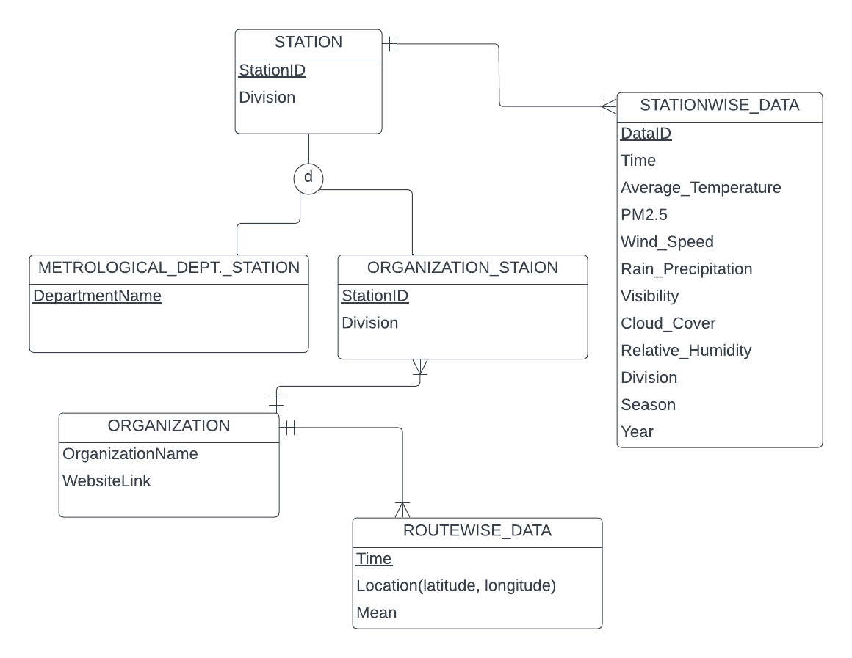

**CHAPTER 05: CONCLUSION**

**PROBLEM AND SOLUTION**

1. As there is not so available information of Air Quality Monitoring System in Bangladesh on the internet apart from their website, we could not input any extra information other than the ones our instructors filled us in with.

2. Since some of us heard about this project for the first time from our faculty, it took quite a long time for us to grasp what this government project was about. The required information was provided by our faculty.